**MongoDB Practice (School DB)**

implemented a school data base example by using all CRUD operations using mongoDB in two different ways:

1. Directly writing the parent details in student collection
2. Connecting two different tables using the reference.

**Adding DB:**

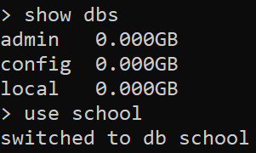

**Inserting Student document:**

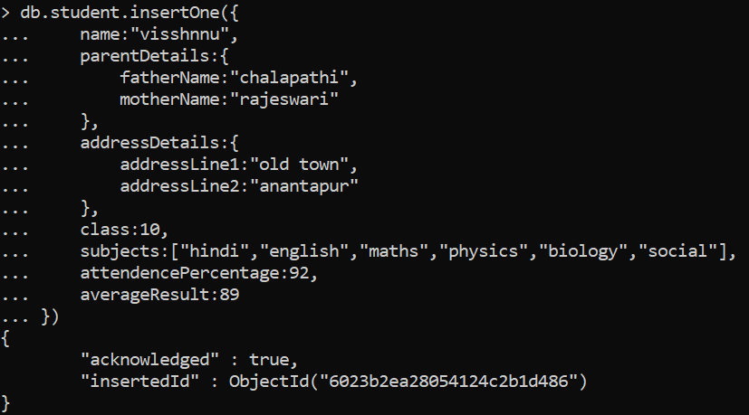

**Getting the document:**

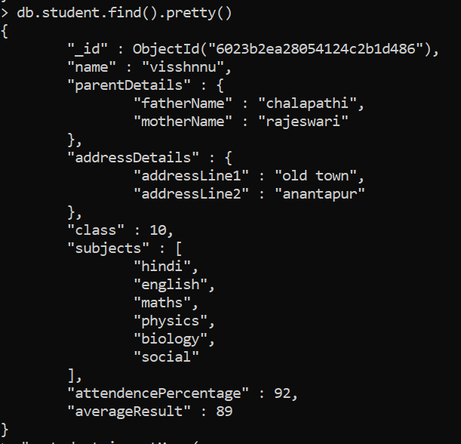

**Inserting many documents:**

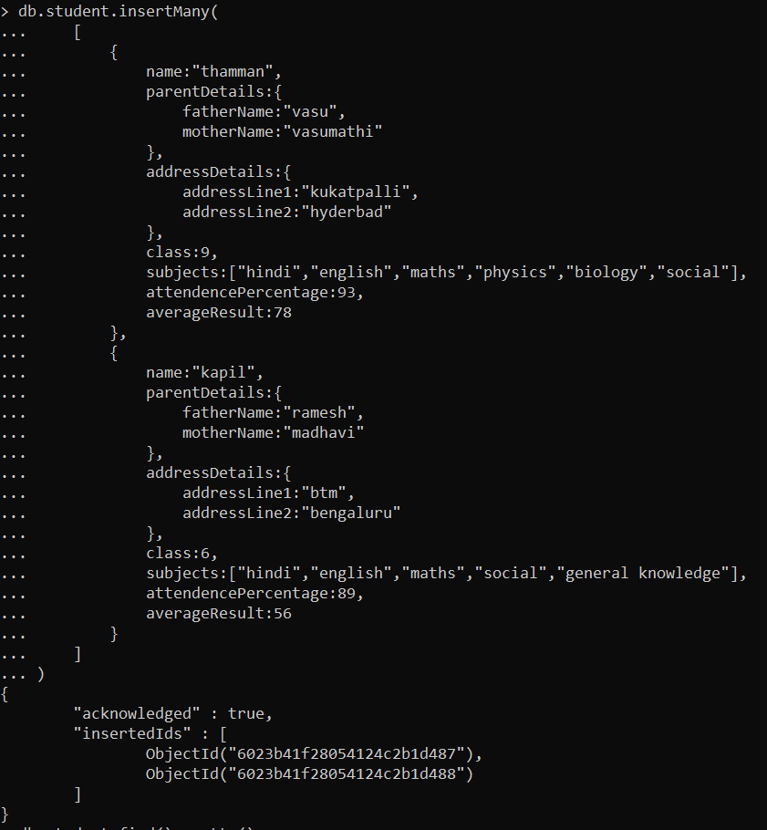

**Getting Data of three recorde:**

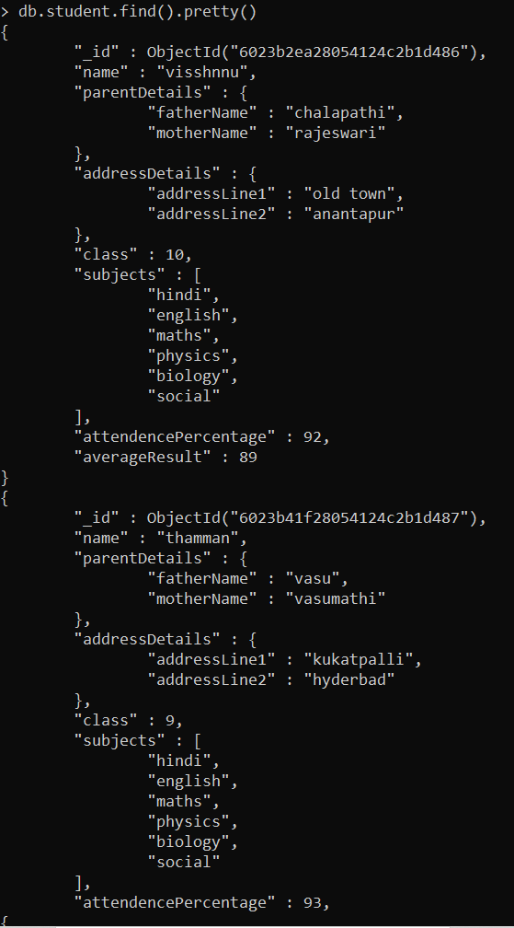

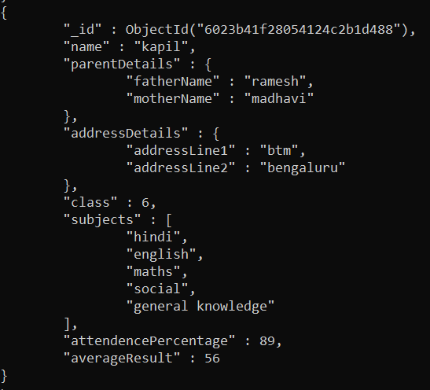

**Manipulating the data for student kapil:**



**Getting the result: (notice the class of kapil is changed)**

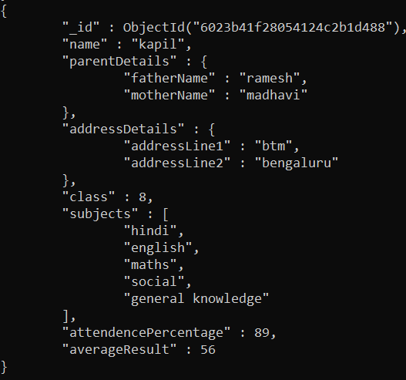

**Deleting kapil record:**



**Getting the output:**

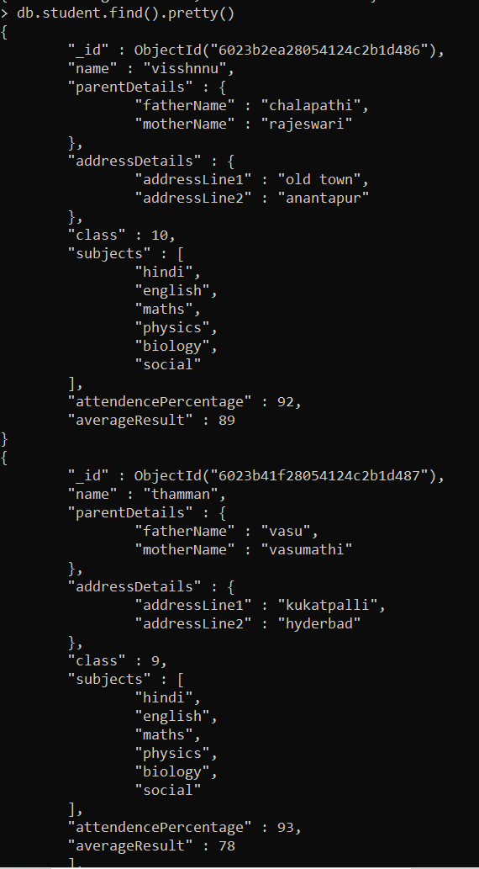

**Inserting Kapil record with out address details, parent details,**

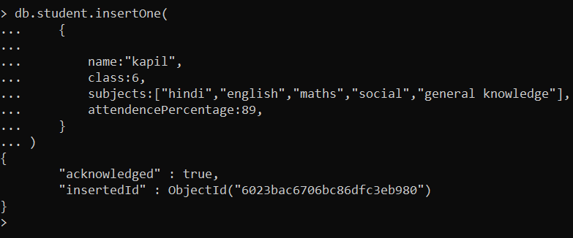

**Creating parent details, address details in separate collection:**

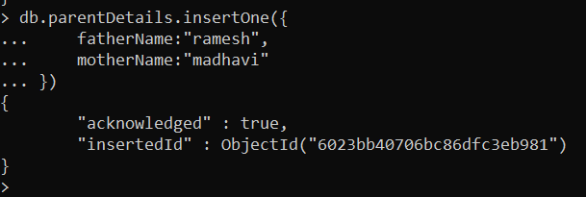

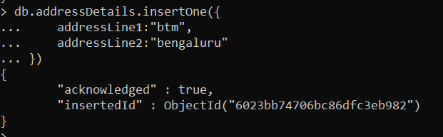

**Joining the kapil record with the parent details and address details by reference:**

